ComPuzzle
CMSC-4900
Fall 2024

Project Requirements
October 15^{th,} 2024

Instructor Comments/Evaluation:

^{Table of Contents:}
Abstract______________________________________________________________________1Introduction __________________________________________________________________1
Background ____________________________________________________________1
Overview/Objectives _____________________________________________________2
Constituents/Team Details & Dynamics ______________________________________3
Application Domain ___________________________________________________________4
Project Context _________________________________________________________4
Initial Business Model _________________________________________________________5
Operational Environment _________________________________________________5
Description of Data Sources _______________________________________________5
Use Case UML Diagrams _________________________________________________6
Initial Requirements ___________________________________________________________9
Functional _____________________________________________________________9
Nonfunctional _________________________________________________________10
Documentation ________________________________________________________11
Testing/Revisions ____________________________________________________________12
Reference Page______________________________________________________________12
Appendix: Technical Glossary __________________________________________________13
Appendix: Team Details _______________________________________________________14
Appendix: Workflow Authentication _____________________________________________15
Appendix: Report from Writing Center ___________________________________________16

Abstract
We created this document as an overview of the steps and methods we intend to take to complete our programming project, as well as a summarized version of what our application will include. For this project, we are making an educational coding game. Our plan is to design a video game application that will entertain while helping the user learn simple coding ideas. This game will include a character navigating a maze with blocks of pseudocode that the user must arrange in the correct order to progress. The user will encounter obstacles to overcome along the way. Progression will be met with harder difficulties including more complicated coding concepts, larger mazes, and additional obstacles. These ideas will be implemented through the Godot coding language, using the Godot game engine. Our team will be assigned separate roles to best fit our individual strengths to complete this project.
Introduction
Background:
Electronic usage only continues to grow as time goes on. Whether it is your phone, computer, or television, there is always a distraction from everyday life. Without even realizing it, so much time is wasted through the unproductive intake of needless online content. This includes video games. In this day and age, everyone loves video games. Video games can be one of these distractions from life — from learning. Who can say they know someone that procrastinates on their schoolwork or studying by playing a video game? Maybe you, personally, can relate to this. Why not play a video game that is not only fun but may also sharpen your mind and help you practice your problem-solving skills?
Our program intends to mesh learning and gaming. This is not to say that you can ignore your textbook and study by playing our game. At least if you procrastinate with this game you may leave with more focus and knowledge than you had before. We want to design this game to make learning the basic programming essentials simple and fun. Something that will keep your attention while practicing your knowledge.
Overview/Objectives:
Our objective is to construct a 2D, top-down, video gaming platform that helps teach the user basic pseudocode/coding practices through the use of a puzzling maze. The goal is to make something not only enjoyable to play, but something that will help the user develop an eye for general coding knowledge/execution. Through various pseudocode snippets, the user must navigate through a maze to escape and complete the level.
These given blocks of pseudocode will need to be correctly chosen among a bank of options and dragged into a sensible arrangement that will guide the character through the maze. The options bank will appear on one side of the screen, the maze and character on the other. You can drag blocks of pseudocode into the slots to manipulate the character’s every move. The character side of the screen is untouchable, only the pseudocode can be used to move the character.
Obstacles will be encountered along the way. The correct arrangement of these pseudocode blocks will allow the user to pass these obstacles and steer through the level. The arrangement of pseudocode will be situational; some options may not be helpful in certain scenarios, and some orders may be more efficient than others. You may unlock easter eggs through efficient solutions. More challenging difficulties can be reached as the user progresses through each maze level. These difficulties will not only include larger mazes with added obstacles, but a more complicated pseudocode arrangement that will delve into harder coding concepts.
To help convey an understanding of our gameplay, a simple example has been created. This example would ask you to envision a character in a maze. Assume that a corridor takes a certain number of steps to walk down. If the character walks a step too many, they will fall into a deathtrap/obstacle at the end. The user would need to arrange the given pseudocode blocks into a functional order to walk just enough to not fall in. One solution may be to arrange blocks of a for-loop containing initialization, conditions, and/or iteration. When arranged in the correct order and with the correct variable, the character will walk just enough to not fall in and continue the maze. When arranged in the incorrect order, the character will either not move at all, not walk far enough, or walk too far and fall into the trap, depending on how off the arrangement/variable was. Certain inaccuracies may leave the character unscathed and able to retry; others may make you restart the level completely. This example is not all-inclusive and is meant to give the reader an easier understanding of our gameplay.
Constituents/Team Details & Dynamics:
The majority of the workload will be done in a team effort, but separate roles will be allocated to fit each member’s strong suits. The role each member receives will be their main focus, and they will lead the rest of the team in their specialty. Divvying into different workloads will aid in an efficient and structured workflow.
Team Member: | Major: | Leadership Phase:
Abigail Dehart | CS | Design
Brianna Dulik | CS | User Manual & Presentation
Brandon Mastin | CS | Specification/Analysis
Cameron McGill | CS | Implementation
Abigail’s leadership will focus on the design of the game. This will include graphics, level design, and mechanics. Brianna’s leadership focus is on the user manual, the nitty gritty of how to maneuver our game. As well as presentation, displaying our updates and progress to the audience. Brandon’s leadership focus is on specification/analysis, the breaking down of efficiency in executions and making informed decisions on what is best for the code long term. Cameron’s leadership focus is on the actual implementation of our chosen ideas with code. Of course, our team will work together to reach these goals, but each segment will be led by its respective leader.
Application Domain
Project Context:
The ComPuzzle application is meant to connect learning and video gaming. Though we are not the first to mix coding into a fun game, we want to make ours simple enough for even non-programmers to play and enjoy. Anyone of any level, whether they have experience in the programming field or not, will be able to play our game. Not only will it teach problem-solving skills, but it will also give the user a feel for certain coding ideas and concepts. Manipulating the character with blocks of pseudocode will show the user a visual representation of what will happen with certain arrangements/combinations of code. This is a great way to interactively learn code. Interactive learning is a simple yet effective way to teach someone the fundamentals of programming.
Initial Business Model
Operational Environment:
ComPuzzle will be aimed, primarily, towards beginner students interested in Computer Science. We want to help students learn and practice their knowledge with an engaging video game. Computer programming can be hard. Making a video game that can help students delve into some basic coding ideas may help to wipe away those starter fears. Since this game will include less complicated concepts and pseudocode examples, intermediate programmers may find the solution comes easy to them. Though programmers may have an easier time progressing through our game, it could still help them refresh, reconsider, or simply be a fun way to reassess topics. Our main aim may be towards beginner students, but we want everyone to enjoy our game. Different difficulty levels will ensure that anyone can play. Whether you are just getting into coding concepts, or you code daily, we want our game to be a captivating learning experience.
Description of Data Sources:
Our program’s data sources include data saved from the user. UI settings, levels completed, and steps taken to complete each level will be collected from the user and saved to a file. This allows the user to be able to pick up where they left off, with the preferred settings they previously chose. A reliable saving system is necessary. Without a saving system, users would not be able to start up where they left off, and with the difficulty they made it to. No one wants to play a game that makes you start at level one every time you log on. A game that will keep track of user settings and progress is one that will be played more than just once.
Use Case UML Diagrams and Descriptions: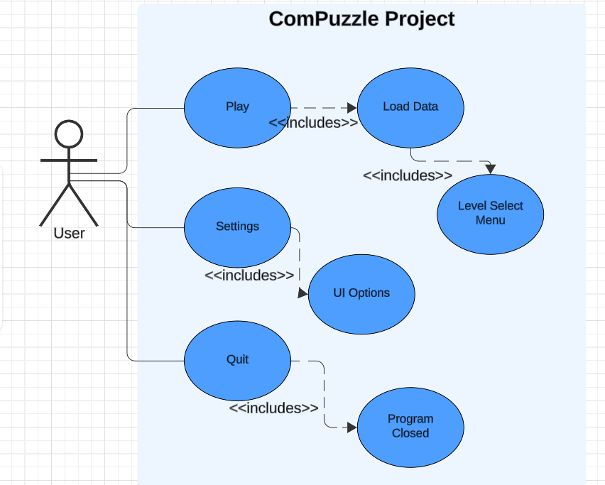Figure 1: Use case UML diagram depicting initial home interactions.
Description: This diagram represents the options available when opening our program. The “Play” button will load your personal saved data and bring you to the level selection menu. The “Settings” button will bring you to UI customization options. The “Quit” button will let you exit the application. “Play” and “Settings” will include a back button in case you want to go back.

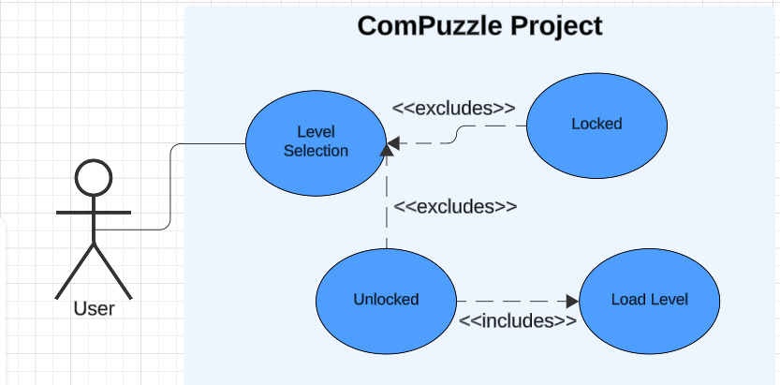Figure 2: Use case UML diagram depicting level selection.
Description: This diagram shows the user selecting a level to play. The level the user tries to select may be locked or unlocked. In the case that it is locked, nothing will happen. The level will be locked if you have not beaten the previous level. In the case that it is unlocked, the level will be loaded. This peeks into progression in our game. Harder levels must be unlocked by beating the previous level first.

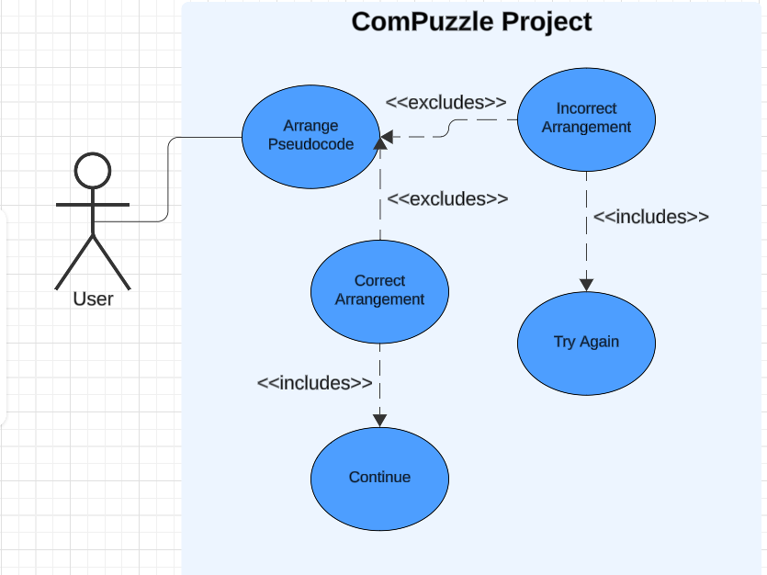Figure 3: Use case UML diagram depicts gameplay.
Description: When arranging blocks of pseudocode, you may get a correct or incorrect solution. In the case that your solution is incorrect, you must try again. You may have to restart the level depending on the obstacle/task you fail. This will also depend on the difficulty level. The user will have to try again either in their failed obstacle or in the level. The manipulated character may mess up detrimentally or simply fail to pass an obstacle/complete a task. In the case that your solution is correct (whether or not it is the fastest solution), you have passed whatever obstacle you faced, and maybe even completed the level. In the case that you have completed the level, your progress will be saved, and the consecutive level will be unlocked.

Initial Requirements
Functional:
The biggest component in making our game will be the game engine and the language we use. We have chosen to use Godot. Godot is a free, open-source game engine. It is known for being lightweight. Since it is optimized for smaller, 2D projects, this engine is the perfect fit to program our game on. It provides exceptional performance for 2D games. Since this engine has so many customization options, we will be able to provide optimization across multiple platforms. Godot comes along with its own language, GDScript; a language similar to Python and known to be easy for programmers to pick up.
This game engine comes with many helpful tools for the programmer. A built-in physics engine will come in handy— mainly when adding in a collision system for the walls, character, and surrounding objects. Designing our graphics will be easily done with precise pixel art, tile maps, shaders, sprite management, animation, and effects like particles that this game engine supports. Our game will have its own unique pixel-art style, drawn by us. This engine allows for easy animation creation. Smooth transitions can be made between movements of characters.
We can easily work on this game together using GitHub. GitHub fully supports Godot, allowing for easy collaboration with automatic updates. It also comes with version control, meaning that it will be easy to see who did what, and when. We can also backtrack, if ever necessary. Discord will be our main means of communication. Through Discord we can text, voice call, or share our screens to relay what we are working on. We will be able to test for bugs in real-time with the testing environment in Godot. Bug-testing will be done periodically by the team to ensure functionality and early notice of any problems. Our game will stay in good operating condition as long as we keep up on testing and revising our program as we code. We hold ourselves accountable to write only quality code to keep organization and efficiency.
Though Godot does not have a built-in sound system, it is easy to import audio files. We plan to make our own sound effects and music. We plan to do this using a free audio editor. With an audio editor, we can mix music for the background, and even record our own sounds. We can create any original melody we like. Sound effects can be recorded and then edited to create a better fit for whatever action it goes along with. A good mic and audio editor will allow for quality music and sound effects, with a high level of control over them.
Nonfunctional:
There are several nonfunctional requirements for this project, including: performance, usability, reliability/compatibility, and scalability. These are the most prominent that we recognize.
Performance is a big concern. This includes frame rate, loading times, and overall response time. Our game will be relatively small and non-taxing for most hardware. We are unaware of the quality, age, and performance of the machines that will run our game. This is out of our control, meaning all we can do is our best to ensure optimization. It is in our best interest to make this game lightweight and efficient for any hardware that it will be run on. Efficient coding practices, realistic performance goals, and testing on various hardware devices are things we can do to aid in performance on any device.
Usability is how easily the user can understand how to interact with and play our game. This includes their familiarity with the given pseudocode, familiarity with how to solve puzzles, the ability to connect the code to solving the puzzle, and things such as controls and interface. Our user manual will aid in the learning of controls and the how to’s. Multiple difficulties starting at beginner level will help ease the user into coding concepts and maze solving. An outsider looking into and testing our game will help us know what we can change/ improve for usability.
Reliability and compatibility are of considerable importance, and they go hand in hand. Unexpected crashes and bugs may happen depending on if our program is run on a different piece of hardware. Our efforts will lie in implementing proper error handling to handle these possibilities. Having outsiders, again, test our game but on different platforms can help in the early catching and prevention of these bugs.
Early-on implementation of proper coding practices that allow for scalability, performing regular maintenance, and testing our code not only as a team but with third parties will help us assist the nonfunctional aspects that affect our program.

Documentation:
Documentation is necessary for detailed planning of how we will tackle this project. This includes tracking when things were done, and by whom. Each team member’s individual work has been and will be reported. Holding to these steps keeps everything organized and efficient. Here are the steps, as mentioned in the requirement document specifications.
- Proposal Document
- Requirement Document
- Specification Document
- Design Document
- Project Log
- User Manual
Testing/Revisions:
This document was written in collaboration with the whole ComPuzzle team. All topics, plans, ideas, and proposals were met and agreed upon as a group. A shared document was made, and each group member would receive automatic updates/comments that were performed. This allowed everyone to work together with ease. In person or not, real-time updates could be seen and communication made for plans/progress. After a collective draft was completed, proofreading was done, and edits were made by everyone according to their satisfaction.

Reference Page
Aupperlee, A. (2021, September 30). New Research Shows Learning Is More Effective When Active. Carnegie Mellon School of Computer Science. https://www.cs.cmu.edu/news/2021/yannier_koedinger_active_learning
Brame, C. (1970, August 7). Group work: Using Cooperative Learning Groups Effectively. Vanderbilt University. https://cft.vanderbilt.edu/guides-sub-pages/setting-up-and-facilitating-group-work-using-cooperative-learning-groups-effectively/
Festing, M., & Schumacher, T. (2021). Playing to Learn: Serious Games in Higher Ed | AACSB. Www.aacsb.edu. https://www.aacsb.edu/insights/articles/2021/05/playing-to-learn-serious-games-in-higher-ed
GameCloud. (2024, May 15). The Evolution of Compatibility Testing in Game Development. GameCloud. https://gamecloud-ltd.com/the-evolution-of-compatibility-testing-qualityreality-for-a-diverse-world/
Godotengine/godot. (2020, September 29). GitHub. https://github.com/godotengine/godot
Introduction — Godot Engine latest documentation. (2024). Readthedocs.io. https://godot-doc.readthedocs.io/en/3.0/about/introduction.html
Özyer, & Altınsoy. (2023). The role of problematic internet use, self-regulated. Malaysian Online Journal of Educational Technology. https://files.eric.ed.gov/fulltext/EJ1376164.pdf
Scherer, R., Siddiq, F., & Sanchez-Scherer, B. (2021, September 8). Some Evidence on the Cognitive Benefits of Learning to Code. Frontiers in Psychology; Frontiers Media S.A. https://www.frontiersin.org/journals/psychology/articles/10.3389/fpsyg.2021.559424/full
Stanford, S. U., & Notice, C. 94305 C. C. T. (2023). How Games Can Boost Your Learning |. Gdt.stanford.edu. https://gdt.stanford.edu/why-games-are-good-pedagogical-tools/

Appendix: Technical Glossary
Github – A web-based platform that includes version control and collaboration for developers to store, manage, and work on code simultaneously as a group.
Godot – An open-source game engine used for 2D or 3D game development. Flexible and includes many helpful tools in game creation. Includes its own scripting language called GDScript.
Physics engine – A component in video game making used to emulate the laws of physics.
Pseudocode – A simple and informal way of writing programming logic. No specific syntax required.
For-loop – A control flow statement in programming utilized to repeat a block of code a specific number of times. Continues to execute as long as its condition is true.
UI – User Interface. Includes the visuals, buttons, settings, menus, that the user will see and interact with.
Python – A high programming language.
Scalability – The ability of a system or application to accommodate increasing growth.
Hardware – Physical components of a computer, such as the central processing unit (CPU), memory (RAM), hard drives, graphics cards, motherboards, etc. The backbone of a computer.

Appendix: Team Details
Though work was completed by all, each team member had a primary focus. We worked on this paper as we will work on the ComPuzzle Project: with sections allocated to each member that they will lead in. After completing their writing, the work was proofread and feedback given by the rest of the group. The section leaders were as follows:
Abigail Dehart- Workflow Leader, “Use case” UML diagrams with description, Functional, Nonfunctional, properly cited scholarly resources.
Brianna Dulik- Overview/Objectives, Constituents/Team Details & Dynamics, Project Context, Operational Environment.
Brandon Mastin- Title Page, Table of Contents, Appendix: Technical Glossary, Appendix: Team Details, Appendix: Workflow Authentication.
Cameron McGill- Abstract, Glossary, Description of Data Sources, Initial Requirements, Documentation.
Testing/Revisions were done by all.

Appendix: Workflow Authentication
I, Abigail Dehart, agree with the details, writings, and arrangements mentioned in this document, along with the authenticity of this paper.
10/20/2024
I, Brianna Dulik, agree with the details, writings, and arrangements mentioned in this document, along with the authenticity of this paper.
10/20/2024
I, Brandon Mastin, agree with the details, writings, and arrangements mentioned in this document, along with the authenticity of this paper.
10/20/2024
I, Cameron McGill, agree with the details, writings, and arrangements mentioned in this document, along with the authenticity of this paper.
10/20/2024

Appendix: Report from Writing Center
-Refer to email on 10/21/2024 from Rebekah Schrack.

